G Countries
ROUND 1

You are a wealthy country that sells green beads in the global economy. You will be visiting the LDC countries and trading green beads for red beads.

The first thing you need to do is fill out a nametag so that you can be identified by the other players in your class. Your name tag should read: G1.

Next, you must go to your local banker to collect the following items:
- Your first round of green beads
- $100 Million for trading
- Your first round of trading instructions
- Budget sheet
- Health and education budget sheets

The main objective in trading is to ensure that your health and education services continue to run smoothly. This is achieved by selling green beads to LDCs. You can use the profits from selling green beads to invest in your health and education. There are two rules when filling out your health and education budgets:

- You must spend all your earnings on health and education. (You will be given $100 Million from your local banker once you have deposited your health and education investments)
- You must spend a minimum of $100 Million on health and education each round. If you do not have enough money, you will have to borrow from the World Bank and IMF.

Read your trading card. Your teacher will let you know when it is time to start trading.

World Bank IMF
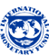

You are the representative for the World Bank and IMF. The World Bank was one of several financial institutions set up at the end of World War II which aimed to produce an international post-war economic system. The World Bank lends money for long-term development and loans must be repaid over fifteen to twenty years.

The IMF mandate is to regulate an international monetary system to facilitate global trade. It also lends money to members having trouble meeting their financial obligations to other members on the condition that they undertake economic reforms.

The local banker will hand you your trading card and loan sheet before the first round.
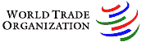
The General Agreement on Tariffs and Trade was established in 1948 to resolve trade disputes though a series of negotiating rounds. It comprised of 23 of the richest Western countries. At the Uruguay Round in 1987, it was decided that a more formal institution was needed to enforce trade-related decisions. In 1995, the WTO was established to enforce free market values on the global economy with the use sanctions and fines.

The local banker will hand you your first trading card before the first round.

LDC 1
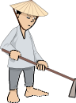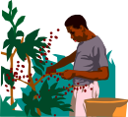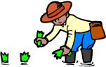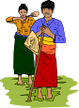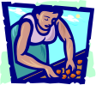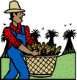

You are a developing country that sells red beads in the global economy. You will be visiting the G countries and trading red beads for green beads.

The first thing you need to do is fill out a nametag so that you can be identified by the other players in your class. Your name tag should read: LDC 1.

Next, you must go to your local banker to collect the following items:
- Your first round of red beads
- $100 Million for trading
- Your first round of trading instructions
- Budget sheet
- Health and education budget sheets

The main objective in trading is to ensure that your health and education services continue to run smoothly. This is achieved by selling red beads to G Countries. You can use the profits from selling red beads to invest in your health and education. There are two rules when filling out your health and education budgets:

- You must spend a minimum of $100 Million on health and education. If you do not have enough money, you will have to borrow from the World Bank and IMF.

Read your trading card. Your teacher will let you know when it is time to start trading.

